|  |  |  |  |  |  |
| --- | --- | --- | --- | --- | --- |
| Date | 7-Dec-22 | | | Tester Name | Richard Belanger |
| Environment | Penfax - Test | | | Login used | TEST2 |
| Operating System | Windows | Version: | Update: | | |
| Software Used | Edge | Version: | Update: | | |
| Not Applicable | Version: | Update: | | |
| Release version | 22.4.1 | | | | |
| Title | M45.02 Running the batch PSSP | | | | |
| Test Type | Regression | | | | |
| Test Scenario | Run the PSSP Tax slip Batch | | | | |
|  |  | | | | |
| Expected Results | Batch will complete successfully, Files created | | | | |
| Pass/Fail | Pass | | | JIRA# | N/A |

Describe your steps with screenshots:

Set up Tax slip Batch for PSSP

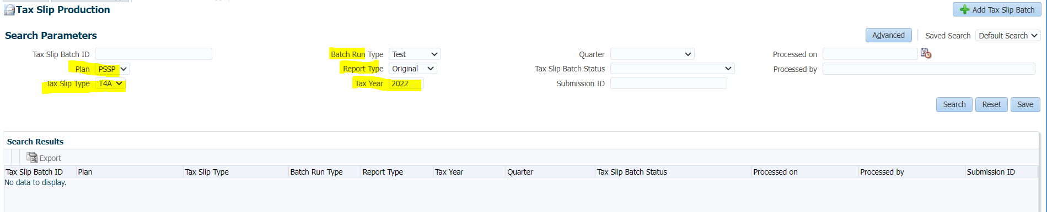

Batch has Completed Successfully>Processed

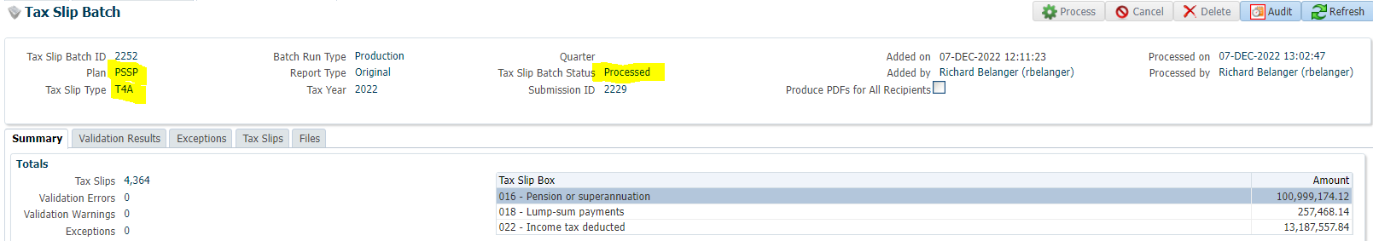

Tax Slips Tab

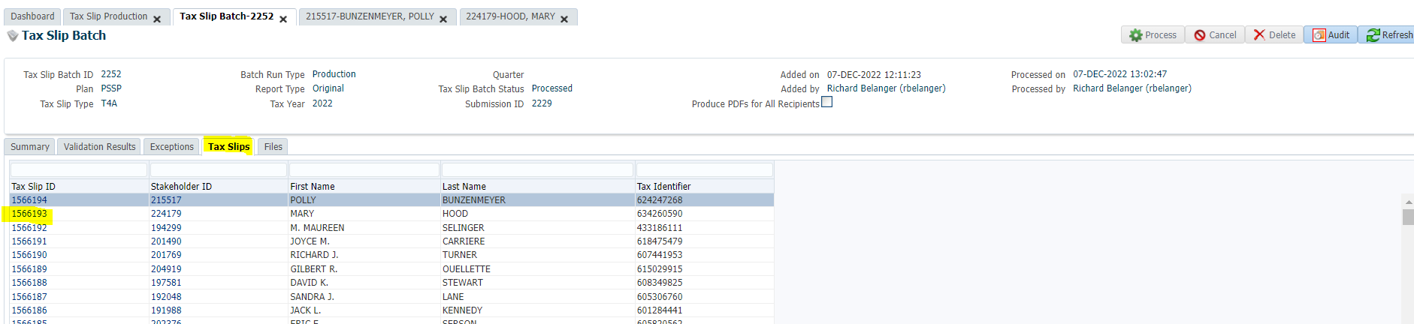

Look at Tax Details = 1566193; SID = 224179

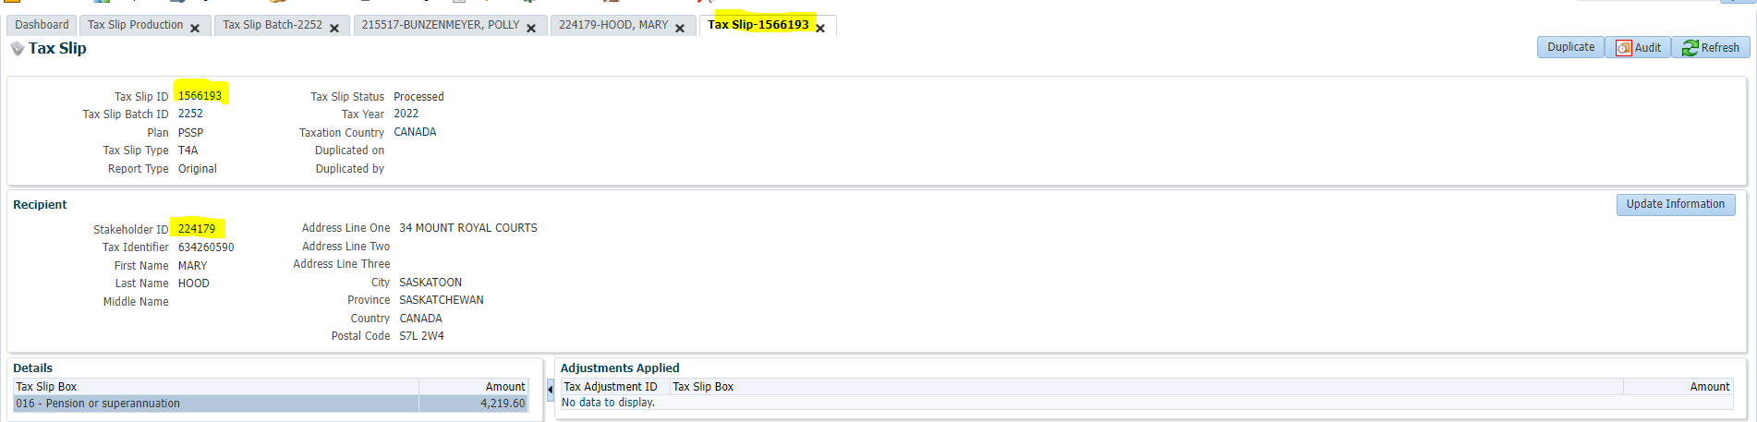Person Profile>Communication>Outbound Documents  
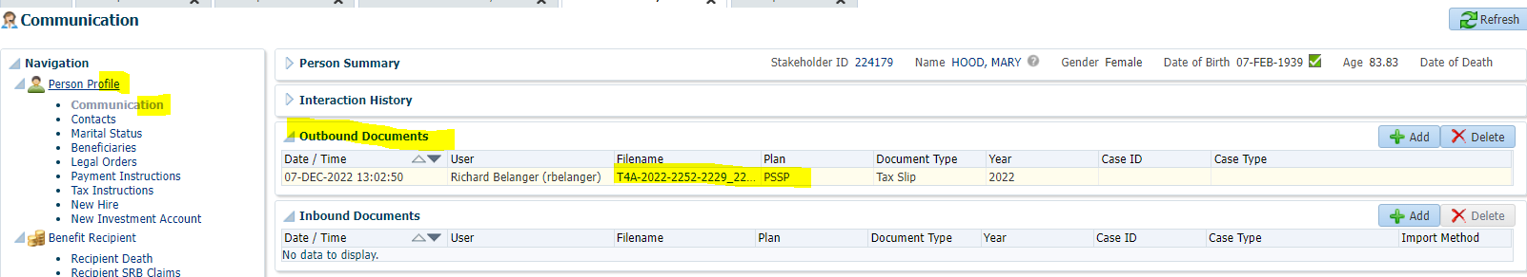

Open .pdf> Box 016 matches Tax Slip details

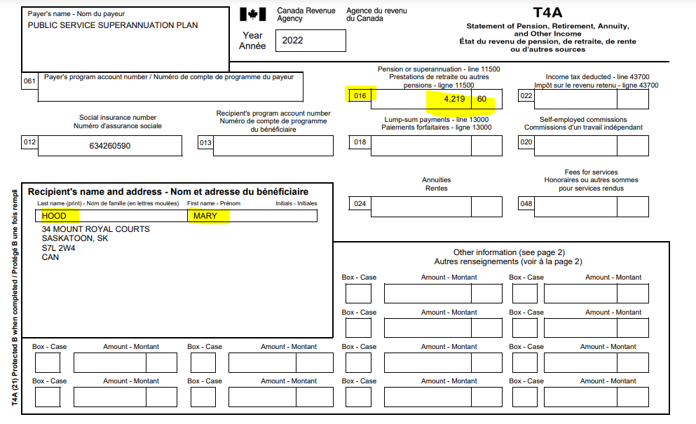

Files Tab

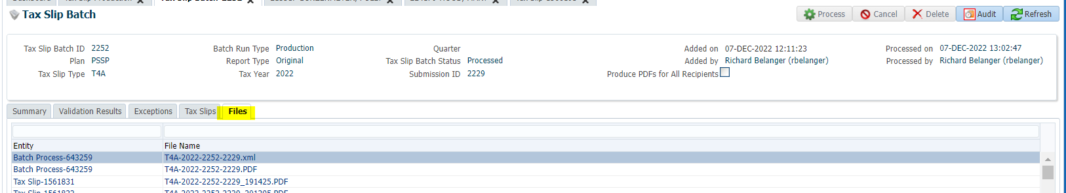

XML File- opens (Wordpad)

